**Matéria - Ingles Particular**

1. **Alphabet**

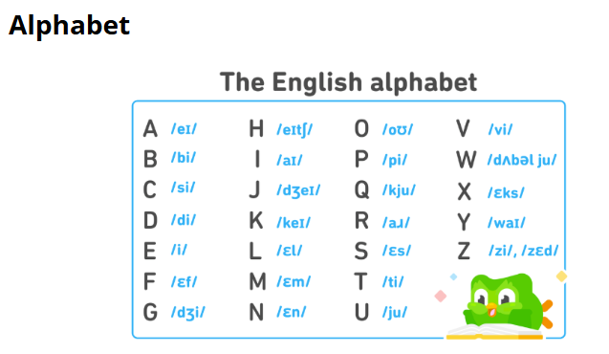

1. **Verb To BE (ser / estar/ idade)**

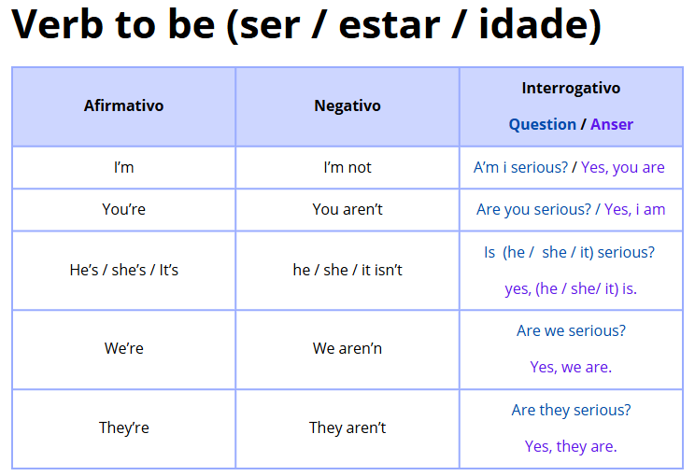

1. **Numbers**

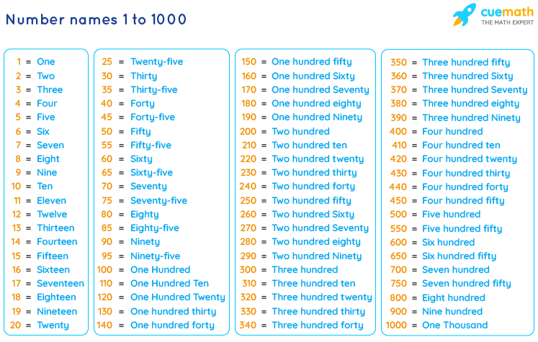

1. **Simple Present - Afirmativo**

## **🧠 Quando usar o Simple Present?**

Usamos o **simple present** para falar sobre:

* **Hábitos e rotinas**:  
   *I wake up at 7 a.m.*
* **Fatos gerais e verdades universais**:  
   *The sun rises in the east.*
* **Situações permanentes**:  
   *She lives in London.*
* **Programações fixas (ex: transportes, eventos)**:  
   *The bus leaves at 8:00.*

## **🏗️ Estrutura – Frases afirmativas**

### **✅ Sujeito + Verbo (no presente) + Complemento**

| **Sujeito** | **Verbo (forma base)** | **Exemplo** |
| --- | --- | --- |
| I | work | I work every day. |
| You | play | You play soccer. |
| We | study | We study English. |
| They | eat | They eat breakfast. |

**Com “he”, “she” ou “it”** adiciona-se **-S, -ES ou -IES** ao verbo:

| **Sujeito** | **Verbo (com -s)** | **Exemplo** |
| --- | --- | --- |
| He | works  [default] | He works at a bank. |
| She | studies  [y] | She studies at night. |
| It | watches  [-ch, -sh, -s, -x, -o] | It watches birds. |

## **✏️ Regras para adicionar -S / -ES / -IES**

### **✔️ Regra 1: Verbos normais → + S**

* work → works
* read → reads
* drink → drinks

### **✔️ Regra 2:** Verbos terminados em **[-ch, -sh, -s, -x, -o] → + ES**

* watch → watches
* wash → washes
* fix → fixes
* go → goes

### **✔️ Regra 3:** Verbos terminados em **consoante + Y → troca Y por IES**

* study → studies
* carry → carries

❗ Se termina em vogal + Y, **só adiciona S**:

* play → plays

## **🔑 Verbo “To Be” no Simple Present (Afirmativo)**

| **Sujeito** | **Verbo “to be”** | **Exemplo** |
| --- | --- | --- |
| I | am | I am a teacher. |
| You | are | You are happy. |
| He/She/It | is | She is at school. |
| We/They | are | We are students. |

## 

## 

## 

## **💬 Exemplos de frases no Simple Present Afirmativo**

* I eat breakfast at 7 a.m.
* She likes chocolate.
* He goes to the gym on Mondays.
* They speak English and Spanish.
* It makes a strange noise.
* We work from home.
* The train leaves at 6:15.

## **🕒 Palavras-chave que indicam uso do Simple Present**

* always (sempre)
* usually (geralmente)
* often (frequentemente)
* sometimes (às vezes)
* rarely (raramente)
* never (nunca)
* every day/week/month/year
* on Mondays, on weekends

Ex: *She always drinks coffee in the morning.*

## **⚠️ Dicas importantes**

* Não usar o auxiliar “do” nas frases afirmativas!  
   (Use “do” e “does” apenas em perguntas e negativas.)
* Cuidado com a **concordância com he/she/it** – lembre-se do **S no verbo**.
* “To be” é irregular e **não segue a mesma regra dos outros verbos.**

**Resumo:**

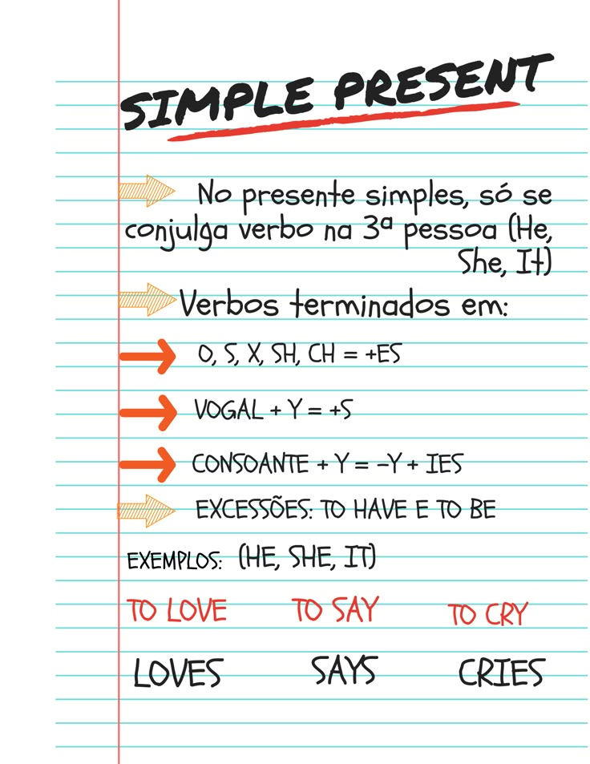

# **Simple Present – Negativo**

## **🧠 Quando usar a forma negativa?**

Usamos a forma negativa para dizer que algo **não acontece** regularmente,

não é verdadeiro, ou não é feito por alguém.

## **🏗️ Estrutura – Frases negativas**

### **✅ Sujeito + do/does + not + verbo (forma base)**

| **Sujeito** | **Auxiliar** | **Verbo** | **Exemplo** |
| --- | --- | --- | --- |
| I / You / We / They | **do not** (don’t) | work | I don’t work on Sundays. |
| He / She / It | **does not** (doesn’t) | play | She doesn’t play tennis. |

🔹 **O verbo principal fica SEM o “s” na negativa.**  Ex: He **plays** → He **doesn’t play**

## **✅ Verbo “To Be” – forma negativa (irregular)**

| **Sujeito** | **Verbo “to be”** | **Forma negativa** | **Exemplo** |
| --- | --- | --- | --- |
| I | am | am not | I am not tired. |
| You | are | are not (aren’t) | You aren’t ready. |
| He/She/It | is | is not (isn’t) | She isn’t at work. |
| We/They | are | are not (aren’t) | They aren’t students. |

## **💬 Exemplos com outros verbos (forma negativa)**

* I don’t like coffee.
* She doesn’t study French.
* They don’t watch TV every day.
* He doesn’t live in Brazil.
* We don’t go to the gym on weekends.
* It doesn’t work properly.

## **🗝️ Dicas importantes**

* Use “**don’t**” com **I, you, we, they**.
* Use “**doesn’t**” com **he, she, it**.
* **O verbo principal nunca leva “s”** na forma negativa.  
   *She likes* → *She doesn’t like* ❌ *doesn’t likes*
* O “**to be**” não usa “don’t” ou “doesn’t”.

## **🧩 Palavras comuns que combinam com negativas**

* never (nunca)
* not often (não frequentemente)
* rarely (raramente)
* hardly ever (quase nunca)

Ex: *He doesn’t* ***usually*** *arrive early.*

*SImple Presente Interrogativo Yes No Question*

*Doble W Question (frase interrogativas que começa com Wh.*

*Expressões de tempo, around, at, late, in, early, until, on*

*IT no plural usa They, levando os verbos a não adicionar o S.*

1 makes

2 looks

3 falls

4 tell

5 compliement

6 see

7 asks

8 Do

10 see

11 smile

12 stops

13 stares

14 hates

15 tell

16 look

17 see

18 smile

19 stops

20 stares

21 see

22 smile

23 stops

24 stares